* Begin by locating the Info Center on the Navigation pane to the left side of your vision window
* Select Projects from the Info Center list
* Go to the search bar in the upper right hand corner and enter your project name or number
* Once your project has pulled up go to the ribbon above your project name and select “Project Review”

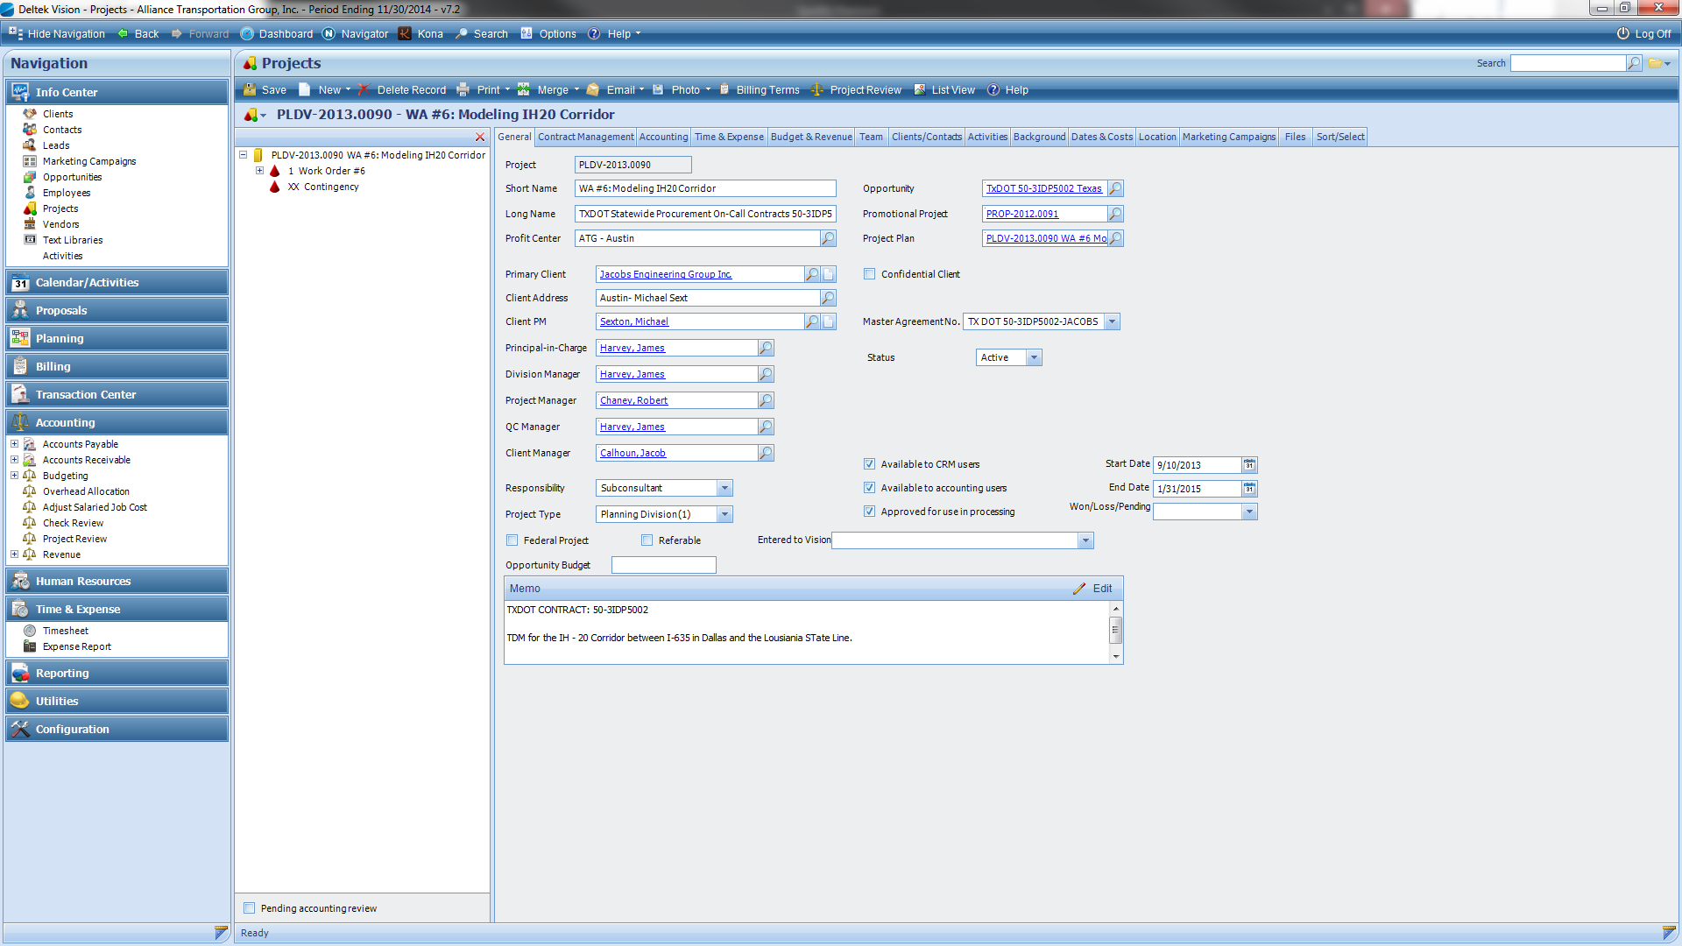

* A new dialogue box will open; choose the “Accounts Receivable” tab
* You can filter the invoices by selecting “All” invoices or only “Unpaid” invoices

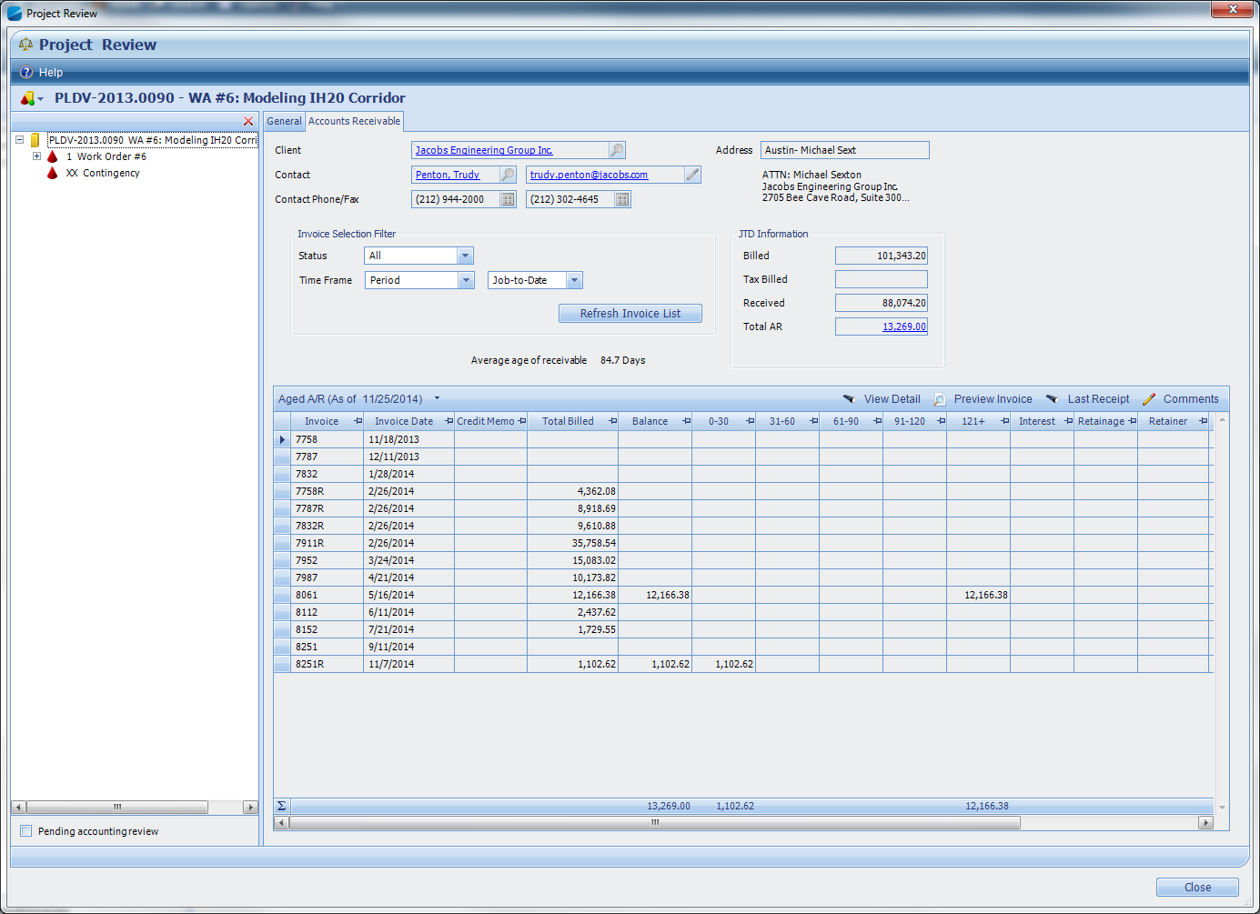

* You can also sort the invoices by Invoice number, Date, or Total Billed
* Click on the invoice you want to record a comment for then select the “comments” option on the right of the AR ribbon:

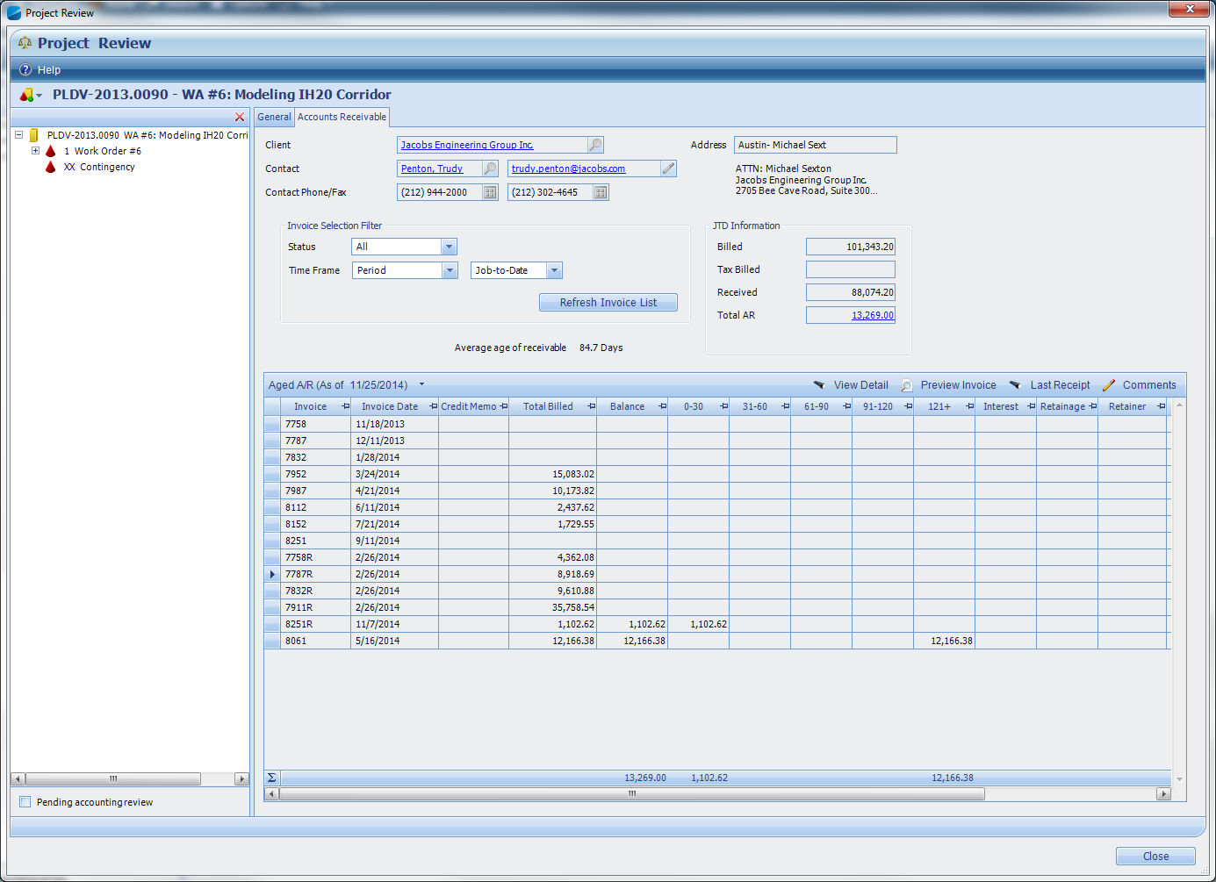

* Once the comments box comes up, you can type or copy and paste the correspondence or updates you have for the invoice:

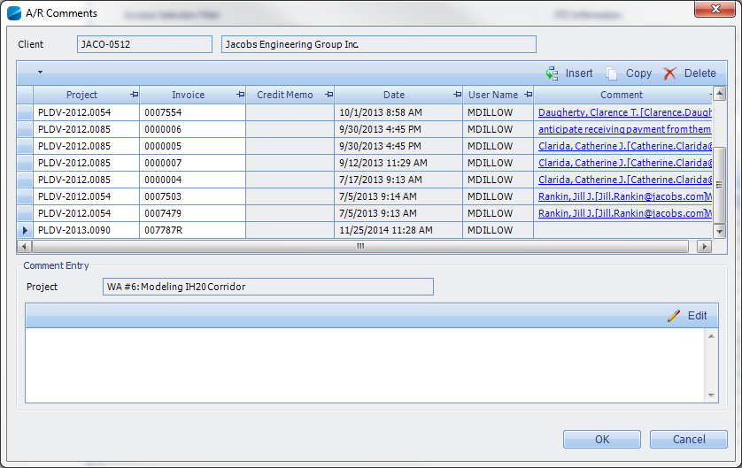

* **Include in the comments for good record who you spoke to, what was discussed, when the correspondence took place, and when payment can be expected so that if anyone else takes over following up on your AR’s they will have the latest info.**
* Hit “OK” when you’re done and this will save the comment.
* To View comments for any other invoice, simply follow the same steps, choose the invoice, click on comments and you’ll be able to view everything for that invoice.
* Make sure the newest comments are always entered on the top.